1. We check if all the services are running using the **jps** command.

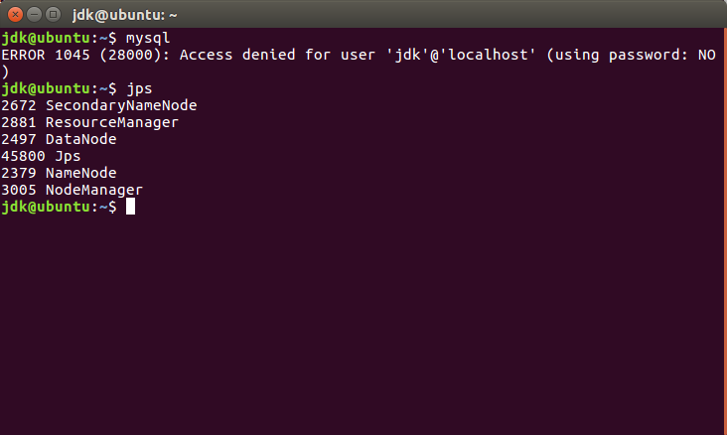

1. Then we start the mysql shell as:

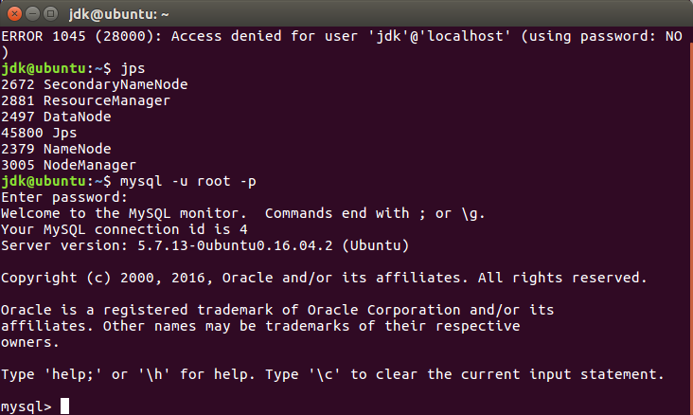

1. We see the list of databases.

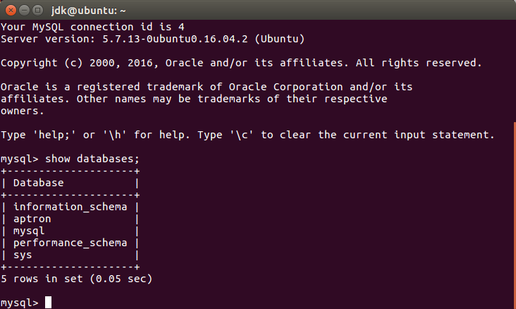

1. We create a new database or use an existing database according to the need.

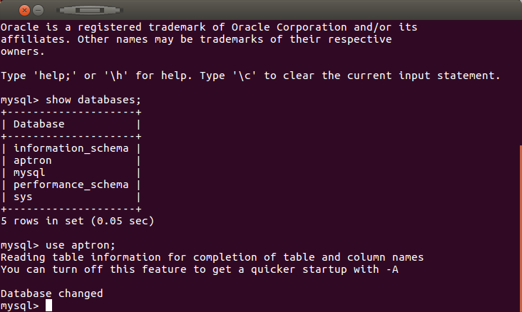

1. Now we create a table in mysql which we will import into HDFS.

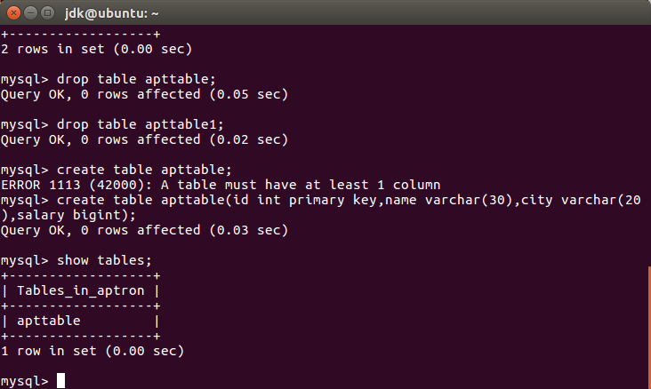

The table is successfully created.

1. Now insert values into the newly created table.

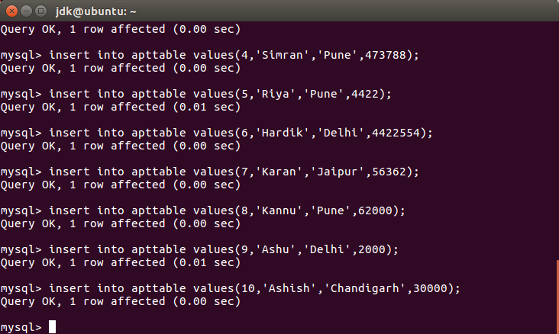

1. We can output the entries of the table as follows:

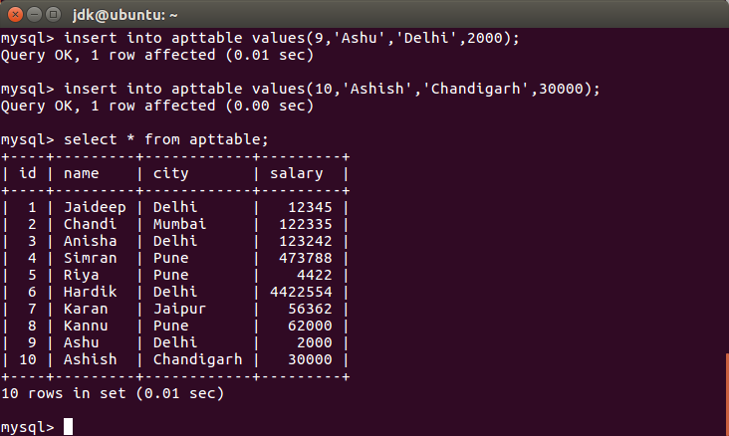

1. Now, we grant privileges to the user so that we can perform import function.

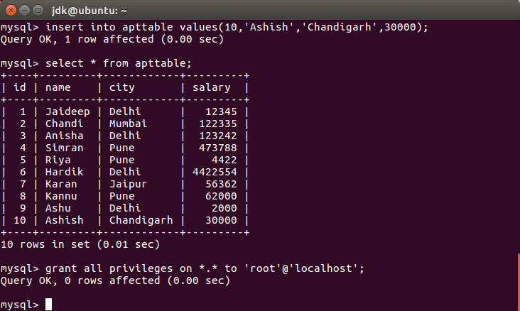

1. After that we quit the mysql shell.

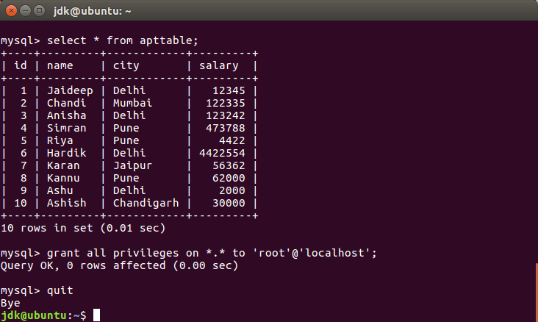

**TRANSFERRING AN ENTIRE TABLE INTO HADOOP:**

1. The command is as follows:

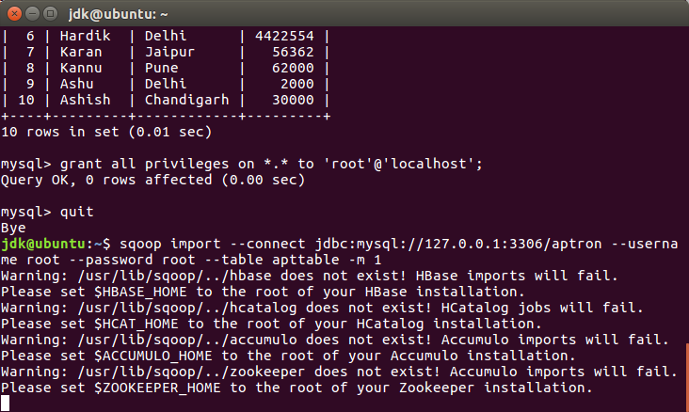

1. Success is achieved. This means that import function has been performed.

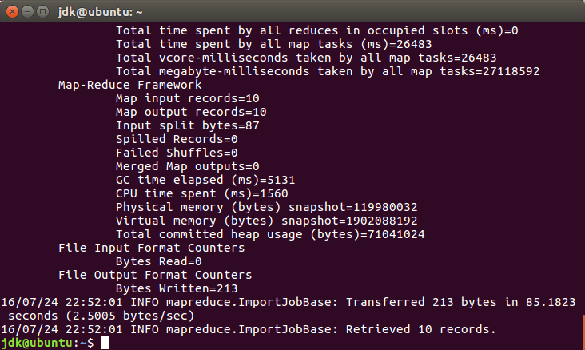

If –m 1 is not used then the output is not saved in a single partition. It makes more than 1 partitions in the hdfs.

1. We can check the output using the cat command.

